Coding question:

The task, calculate the triangle coordinates for an image with right triangles

such that for a given row (AF) and column (1-12) you can produce the layout below:

When looking at a puzzle as the one below there are certain items that jumped at me.

1. All the right triangles are contained in a square that measures 60 at the base and 60 in height.
2. The square contains six rows and six columns.
3. We have twelve right triangles per each row that are right angle.
4. We also have twelve right triangles per each column.
5. There are a total of 36 square and each square contains two right triangles inverted.
6. Each triangle measures 10 at the base and 10 in height.
7. Given the considerations above, the approach I took to build the layout below is to

build one row of the layout at a time. The algorithm iterates a line at a time and builds the layout.

I found this approach to be the quickest way to build the layout.

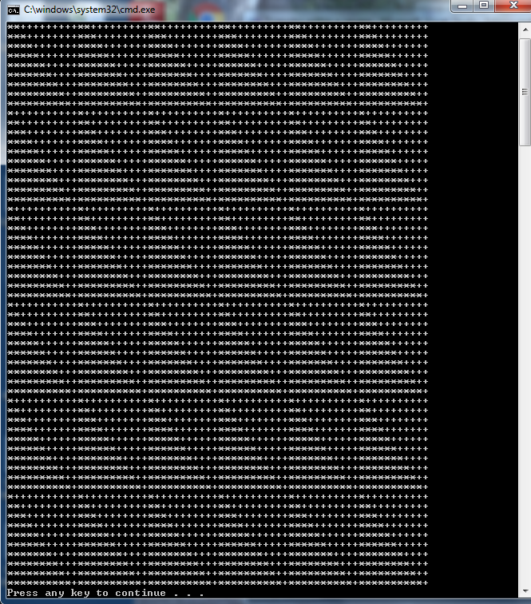

For the second part of the question:

Lastly, given the vertex coordinates, calculate the row and column for the triangle:

There are different ways to achieving this; I am considering the following:

**First Approach:**

1. Given the considerations above one can find the position for example for “C4” as follows:
2. Convert C4s first char into a hex value.
3. Iterate trough the hex values from the first character and from the first triangle for each row. The result would be C = 67 which is the third row.
4. I would take the same approach to find the column.

**Second Approach:**

1. Each triangle has a corresponding vertex address such that: “A1”, “A2”, “A3”, “A4”, “B1”, “B2”, “B3”, etc.
2. Each Letter has 12 triangles in a row and only two triangles per column per square-block.
3. “A1- triangle vertex” has a value that is less than any triangle to its right or than any triangle that is below.
4. “A2- triangles” have a value that is/are greater than triangle(s) to its left, but its value is/are less than those triangles to its right or those below.
5. “C4- triangles” triangle have a value that is/are less than those to in columns to the right (in the same row) or to triangles in rows below.
6. To maximize processor speed The algorithm would need to evaluate LESS THAN(Coordinates) only. The triangle in consideration would be the greater

than and evaluate those with less value.